🍕 Pizza Sales Analysis - SQL Queries

## 1. Total Revenue

Returns the total revenue generated from all pizza sales.

SELECT SUM(total_price) AS Total_Revenue  
FROM pizza_sales;

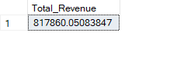

## 2. Average Order Value

Calculates the average order value based on total revenue and number of orders.

SELECT   
 SUM(total_price) / COUNT(DISTINCT order_id) AS Average_Order_Value  
FROM pizza_sales;

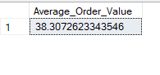

## 3. Total Pizzas Sold

Counts the total quantity of pizzas sold.

SELECT SUM(quantity) AS Total_Pizzas_Sold  
FROM pizza_sales;

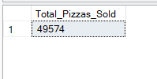

## 4. Total Orders

Returns the total number of distinct orders.

SELECT COUNT(DISTINCT order_id) AS Total_Orders  
FROM pizza_sales;

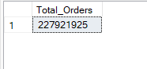

## 5. Average Pizzas Per Order

Calculates the average number of pizzas per order.

SELECT   
 CAST(  
 CAST(SUM(quantity) AS DECIMAL(10,2)) /   
 CAST(COUNT(DISTINCT order_id) AS DECIMAL(10,2))   
 AS DECIMAL(10,2)  
 ) AS Average_Pizzas_Sold_PerOrder  
FROM pizza_sales;

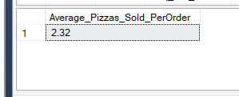

# 📊 Chart Queries

## 1. Daily Trend for Total Orders

Shows number of orders per day.

SELECT   
 COUNT(DISTINCT order_id) AS Number_Of_Order,  
 order_date  
FROM pizza_sales  
GROUP BY order_date;

## ➤ By Day of Week

Displays the trend of orders by weekday name.

SELECT   
 DATENAME(DW, order_date) AS order_day,  
 COUNT(DISTINCT order_id) AS Number_Of_Order  
FROM pizza_sales  
GROUP BY DATENAME(DW, order_date);

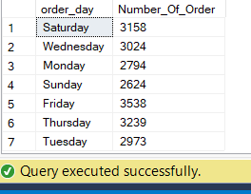

## 2. Hourly Trend

Shows number of orders placed by each hour of the day.

SELECT   
 DATEPART(HOUR, order_time) AS order_time,  
 COUNT(DISTINCT order_id) AS Number_Of_Order  
FROM pizza_sales  
GROUP BY DATEPART(HOUR, order_time)  
ORDER BY DATEPART(HOUR, order_time);

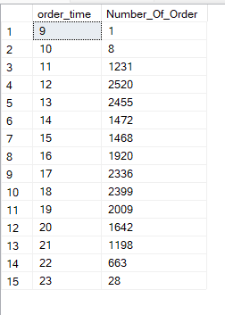

## 3. Sales by Category (January)

Shows sales and their percentage by category for January.

SELECT   
 pizza_category,  
 SUM(total_price) AS Total_Sales,  
 SUM(total_price) * 100 /   
 (SELECT SUM(total_price) FROM pizza_sales WHERE MONTH(order_date) = 1)   
 AS Percentage_Category_Sales  
FROM pizza_sales  
WHERE MONTH(order_date) = 1  
GROUP BY pizza_category;

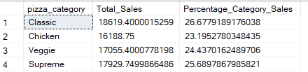

## 4. Quarterly Sales by Category (Q1)

Sales distribution by category for the first quarter.

SELECT   
 pizza_category,  
 SUM(total_price) AS Total_Sales,  
 SUM(total_price) * 100 /   
 (SELECT SUM(total_price) FROM pizza_sales WHERE DATEPART(QUARTER, order_date) = 1)   
 AS Percentage_Category_Sales  
FROM pizza_sales  
WHERE DATEPART(QUARTER, order_date) = 1  
GROUP BY pizza_category;

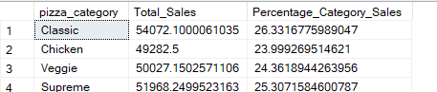

## 5. Percentage Sales by Pizza Size

Percentage of total sales by pizza size.

SELECT   
 pizza_size,  
 SUM(total_price) AS Total_Sales,  
 CAST(SUM(total_price) AS DECIMAL(10,2)) * 100 /   
 (SELECT SUM(total_price) FROM pizza_sales)   
 AS Percentage_Category_Sales  
FROM pizza_sales  
GROUP BY pizza_size  
ORDER BY Percentage_Category_Sales DESC;

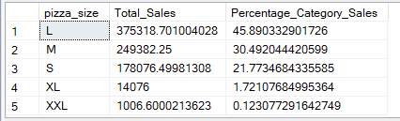

## 6. Total Pizzas Sold by Category

Displays number of pizzas sold for each category.

SELECT   
 pizza_category,  
 SUM(quantity) AS Total_Pizzas_Sold  
FROM pizza_sales  
GROUP BY pizza_category;

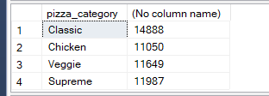

## 7. Top 5 Best Performing Pizzas

Top 5 pizzas based on total quantity sold.

SELECT TOP 5   
 pizza_name,  
 SUM(quantity) AS Total_Sold  
FROM pizza_sales  
GROUP BY pizza_name  
ORDER BY Total_Sold DESC;

